**Topics: Descriptive Statistics and Probability**

1. Look at the data given below. Plot the data, find the outliers and find out , 𝜎, 𝜎2

|  |  |
| --- | --- |
| **Name of company** | **Measure X** |
| Allied Signal | 24.23% |
| Bankers Trust | 25.53% |
| General Mills | 25.41% |
| ITT Industries | 24.14% |
| J.P.Morgan & Co. | 29.62% |
| Lehman Brothers | 28.25% |
| Marriott | 25.81% |
| MCI | 24.39% |
| Merrill Lynch | 40.26% |
| Microsoft | 32.95% |
| Morgan Stanley | 91.36% |
| Sun Microsystems | 25.99% |
| Travelers | 39.42% |
| US Airways | 26.71% |
| Warner-Lambert | 35.00% |

Ans = Mean = 33.271

Std.Dev = 16.371

Variance = 268.004

Outlier =01

2.

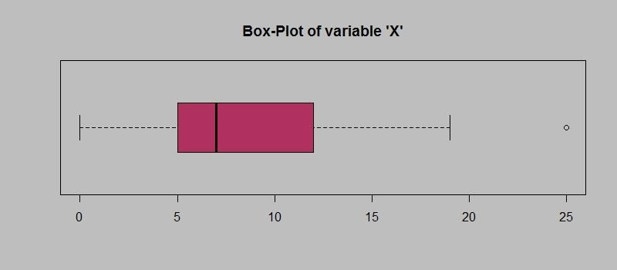

Answer the following three questions based on the box-plot above.

1. What is inter-quartile range of this dataset? (please approximate the numbers) In one line, explain what this value implies.

12.5-5 = 7.5, this value implies that 50% data is covered within the 7.5 length.

1. What can we say about the skewness of this dataset?

Most of the data is concentrated on the left side so thus positive skewness.

1. If it was found that the data point with the value 25 is actually 2.5, how would the new box-plot be affected?

New box-plot will have no outlier and all the datapoints will be inside the boxplot.

3.

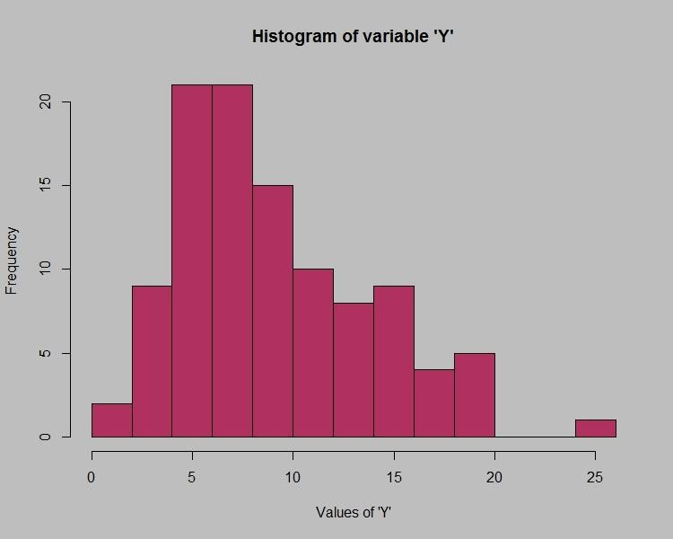

Answer the following three questions based on the histogram above.

1. Where would the mode of this dataset lie?

Ans = Mode lies between 4.8 to 8 (approx.) (values on x axis).

1. Comment on the skewness of the dataset.

Ans = positive skewness

1. Suppose that the above histogram and the box-plot in question 2 are plotted for the same dataset. Explain how these graphs complement each other in providing information about any dataset.

Histogram tells us that most of the data lies between 4.8 to 10 and very less data lies after 20.The same goes with box plot and there is one outlier at 25. With the help of histogram we can see that most of data lies between 4.8 to 10 and with help of boxplot we can see that there is one outlier at 25.

1. AT&T was running commercials in 1990 aimed at luring back customers who had switched to one of the other long-distance phone service providers. One such commercial shows a businessman trying to reach Phoenix and mistakenly getting Fiji, where a half-naked native on a beach responds incomprehensibly in Polynesian. When asked about this advertisement, AT&T admitted that the portrayed incident did not actually take place but added that this was an enactment of something that “could happen.” Suppose that one in 200 long-distance telephone calls is misdirected. What is the probability that at least one in five attempted telephone calls reaches the wrong number? (Assume independence of attempts.)

P(A) = probability of misdirecting call =1/200 = p

P(B) = probability of all call reaching right number = 199/200 = q

Probability that at least one in five attempted call = 1- P(x)

= 1- 5C0*(1/200)0*(199/200)5

= 1- (199/200)5

= 0.0247(Where x= 0 i.e. none of calls are reaching the wrong number,n= 5 calls)

1. Returns on a certain business venture, to the nearest $1,000, are known to follow the following probability distribution

|  |  |
| --- | --- |
| x | P(x) |
| -2,000 | 0.1 |
| -1,000 | 0.1 |
| 0 | 0.2 |
| 1000 | 0.2 |
| 2000 | 0.3 |
| 3000 | 0.1 |

* 1. What is the most likely monetary outcome of the business venture?

Ans= $2000 as it has the highest probability of occurrence.

* 1. Is the venture likely to be successful? Explain

Ans=as its risk probability is less than the profit probability.

* 1. What is the long-term average earning of business ventures of this kind? Explain

(-2000*0.1) +(-1000*0.1) + (0*0.2) +(1000*0.2) +(2000*0.3) +(3000*0.1) =$800

* 1. What is the good measure of the risk involved in a venture of this kind? Compute this measure

Ans =To evaluate the risk for a venture of this kind would be variance or standard deviation of the variable X.

The large value of standard deviation of $1870 is considered along with the average returns of $800 indicates that this venture is highly risky.